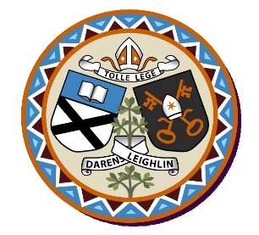
St. Broghan’s National School
Annual Admission Notice

Admission Policy and Application Form
A copy of the school’s Admission Policy and the Application Form for Admission for the 2024/2025 school year is available as follows:
To download at: https://stbroghansns.weebly.com/
On request: By emailing stbroghans@gmail.com or writing to St. Broghan’s NS, Bracknagh, Rathangan, Co. Kildare R51E243

Admissions to the 2024/2025 school year

APPLICATION and DECISION DATES for ADMISSION
The following are the dates applicable for admission to Junior Infants
The school will commence accepting applications for admission | 8th January
The school shall cease accepting applications for admission | 31st January
The date by which applicants will be notified of the decision on their application | 21st February
The period within which applicants must confirm acceptance of an offer of admission | 13th March

Note: The school will consider and issue decisions on late applications in accordance with the school’s Admission Policy.* Failure to accept an offer within the prescribed period above may result in the offer being withdrawn.

SPECIAL CLASS APPLICATION and DECISION DATES for ADMISSION
The following are the dates applicable for admission to the school’s Special Class which caters for children with Autism Spectrum Disorder.
The school will commence accepting applications for admission to the special class | 31st January
The school shall cease accepting applications for admission to the special class | 2nd March
The date by which applicants will be notified of the decision on their application for admission to the special class | 9th March
The period within which applicants must confirm acceptance of an offer of admission | 16th March

Number of Places being made Available in 2024/2025
The number of places being made available in junior infants | 20
The number of places being made available in the special class catering for children with ASD in the special class is | 6

